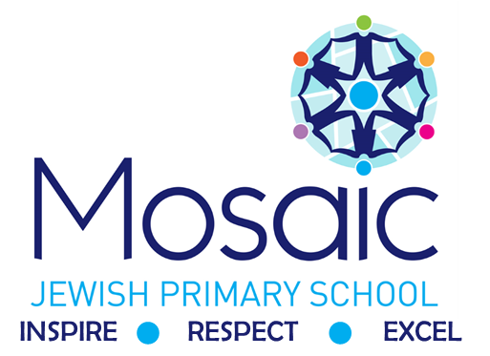

PSHE
Policy

Written: | September 2022 | Reviewed:
Approved: |  | Review Due: | September 2024

Contents

Introduction 3
National Curriculum 4
Teachers planning and organisation 5
Long term planning 5
Medium term planning 5
Lessons 5
Pupils’ Records of work 6
Marking 6
Assessment 6
Medium term 6
Long term 6
Special educational needs & disabilities (SEND) 7
Equal Opportunities 7

Introduction

Inspire, Respect, Excel
At Mosaic, we want pupils to excel both academically, but equally socially and mentally. Our primary aim is to prepare pupils for secondary school and the wider world. Our scheme of work ensures that pupils are given opportunities to explore a wide range of social, emotional, health and economic topics. Whilst fulfilling the values of Judaism, our school community is extremely mixed and diverse, therefore our curriculum has been carefully tailored and adapted to meet the needs of our pupils.

Intent
At Mosaic Jewish Primary School, it is our intent to provide all children with a broad and balanced curriculum that aims to assist children and young people to prepare for adult life by supporting their physical, emotional and moral development, and helping them to understand and respect themselves, respect others as well as forming and sustaining healthy relationships. This will be implemented by creating a programme of study that is bespoke to our school and all our pupils. The two main core themes of our PSHE programme of study focuses on Relationships Education (see separate RSE policy) and Health Education. A third core theme, Living in the Wider World is also an integral aspect of our curriculum.

Impact
The successful approach at Mosaic means by the time our children leave our school they will:
be able to approach a range of real life situations and apply their skills and attributes to help navigate themselves through modern life
be on their way to becoming healthy, open minded, respectful, socially and morally responsible, active members of society appreciate difference and diversity
recognise and apply the British Values of Democracy, Tolerance, Mutual respect, Rule of law and Liberty
be able to understand, manage and express their emotions
be able to look after their mental health and well-being
be able to develop positive, healthy relationship with their peers both now and in the future
understand the physical aspects involved in RSE at an age appropriate level
have respect for themselves and others have a positive self esteem
Contribute to society through social action projects

National Curriculum

Here at Mosaic, we follow the 2020 National Curriculum guidance for PSHE. Pupils will be taught the following:

Relationships Education

Families and people who care for me
Pupils will be taught the following:
• The importance of families for children when growing up, as they can provide love, security and stability
• The characteristics of healthy family life, commitment to each other, including in times of difficulty, protection and care for children and other family members, the importance of spending time together and sharing each other’s lives
• That others’ families within the school or in the wider world may look different from their own, but those differences should be respected, and know that other children’s families are also characterised by love and care
• That stable, caring relationships, which may be of different types, are at the heart of happy families, and are important for children’s security
• How to recognise if family relationships are making them feel unhappy or unsafe, and how to seek help or advice from others if needed

Caring friendships
Pupils will be taught the following:
• The importance of friendships in making us feel happy and secure, and how people choose and make friends
• The characteristics of friendships, such as mutual respect, truthfulness, trustworthiness, loyalty, kindness, generosity, trust, sharing interests and experiences, and support with problems and difficulties
• That healthy friendships are positive and welcoming towards others, and do not make others feel lonely and excluded
• That most friendships have ups and downs, which can often be worked through so that the friendship can be repaired or even strengthened, and that resorting to violence is never right
• How to recognise who to trust and not to trust, how to judge when a friendship causes them to feel unhappy or uncomfortable, managing conflict, how to manage these situations and how to seek help or advice from others if needed

Respectful relationships
Pupils will be taught the following:
• The importance of respecting others, even when they differ from them (for example, physically, in character, personality or backgrounds), or make different choices or have different preferences or beliefs
• Practical steps they can take in a range of different contexts to improve/support respectful relationships
• The conventions of courtesy and manners
• The importance of self-respect and how this links to their own happiness
• That in schools and in wider society they can expect to be treated with respect by others, and should show this respect to others in return, including those in positions of authority
• About different types of bullying (including cyberbullying), the impacts of bullying, responsibilities of bystanders (primarily reporting bullying to an adult) and how to get help
• What a stereotype is, and how these can be unfair, negative or destructive
• The importance of permission-seeking and giving in relationships with friends, peers and adults

Online relationships
Pupils will be taught the following:
• That sometimes people behave differently online or pretend to be someone they are not
• That the same principles apply to online relationships as face-to-face relationships, including the importance of respect for others online (including when anonymous)
• The rules and principles for keeping safe online, recognising risks, harmful content and contact, and how to report them
• How to critically consider their online friendships and sources of information including awareness of the risks associated with people they have never met
• How information and data is shared and used online

Being safe
Pupils will be taught the following:
• What sorts of boundaries are appropriate in friendships with peers and others (including online contexts)
• About the concept of privacy and the implications of it from both children and adults; including that it is not always right to keep secrets in relation to being safe
• That each person’s body belongs to them, and the differences between appropriate and inappropriate/unsafe physical, and other forms of, contact
• How to respond safely and appropriately to adults they encounter (in all contexts, including online) whom they do not know
• How to recognise and report feeling bad or unsafe around an adult
• How to ask for advice or help for themselves or others, and to persist until heard
• How to report concerns or abuse, and the vocabulary needed to do so
• About the dangers they may face, both in and around school and beyond, and how they can keep themselves safe.
• Where to get advice, e.g. family, school, other sources
• Water Safety – understanding the dangers of water and avoidance of these dangers.

Health Education

Mental wellbeing
Pupils will be taught the following:
• That mental wellbeing is a normal aspect of daily life, in the same way as physical health
• That there is a normal range of emotions (e.g. happiness, sadness, anger, fear, nervousness, surprise) and scale of emotions that all humans experience in relation to different experiences and situations
• How to recognise and talk about their emotions, including having varied vocabulary of words to use when talking about their own and others’ feelings
• How to judge whether what they are feeling and how they are behaving is appropriate and proportionate
• The benefits of physical exercise, time outdoors, community participation, voluntary and service-based activity on mental wellbeing and happiness
• Simple self-care techniques, such as the importance of rest, spending time with family and friends and the benefits of hobbies and interests
• Isolation and loneliness can affect children and so it is very important for children to discuss their feelings with an adult and seek support
• That bullying (including cyberbullying) has a negative and often lasting impact on mental wellbeing
• Where and how to seek support (including recognising the triggers for seeking support), including whom in the school they should contact if they are worried about their own or someone else’s mental wellbeing or ability to control their emotions (including issues arising online)
•

It is common for people to experience mental ill health. For many of these people, the problems can be resolved if the right support is made available especially if accessed early enough

Internet safety and harms
Pupils will be taught the following:
• How the internet acts as an integral part of life for most people, with many benefits
• About the benefits of rationing time spent online, the risks of spending excessive time on electronic devices and the impact of positive and negative content online on their own and others’ mental and physical wellbeing
• How to consider the effect of their online actions on others and know how to recognise and display respectful behaviour online and the importance of keeping personal information private
• Why social media, some computer games etc. are age restricted
• That the internet can also be a negative place where online abuse, trolling, bullying and harassment can take place, which can have a negative impact on mental health
• How to be a discerning consumer of information online, recognising that information (including that from search engines) is ranked, selected and targeted
• Where and how to report concerns and get support concerning issues online

Physical health and fitness
Pupils will be taught the following:
• The characteristics and mental/physical benefits of leading an active lifestyle
• The importance of including regular exercise into daily and weekly routines and how to achieve this; for example, walking or cycling to school, a daily active mile or other forms of regular, vigorous exercise
• The risks associated with leading an inactive lifestyle
• How and when to seek support, such as which adults to speak to in school if they have health concerns

Healthy eating
Pupils will be taught the following:
• What constitutes a healthy balanced diet (including understanding nutritional content)
• The principles of planning/preparing a range of healthy meals
• The characteristics of a poor diet and risks associated with unhealthy eating (such as obesity and tooth decay) and other behaviours (such as the impact of alcohol on diet or health)

Drugs, alcohol and tobacco
Pupils in UKS2 will be taught the following:
• The facts about legal/illegal harmful substances and associated risks, including smoking, alcohol use and drug-taking

Health and prevention
Pupils will be taught the following:
• How to recognise early signs of physical illness, such as weight loss or unexplained changes to the body
• About safe/unsafe exposure to the sun, and how to reduce the risk of sun damage, including skin cancer
• The importance of sufficient good quality sleep for good health and that a lack of sleep can influence weight, mood and ability to learn
• About dental health and the benefits of good oral hygiene and dental flossing, such as regular check-ups at the dentist
• About personal hygiene and germs including bacteria, viruses, how they are spread and treated, and the importance of handwashing
• The facts and science relating to allergies, immunisation and vaccination

Basic first aid
Pupils will be taught the following:
• How to make a clear and efficient call to emergency services if necessary
• Concepts of basic first aid, for example dealing with common injuries, including head injuries

Changing adolescent body
Pupils will be taught the following:
• Key facts about puberty and the changing adolescent body, particularly from age 9 through to age 11, including physical and emotional changes
• About menstrual wellbeing and key facts concerning the menstrual cycle

Teachers planning and organisation

Long term planning

The National Curriculum for PSHE 2020, Development Matters, and the Early Learning Goals (Understanding the world) provide the long-term planning for PSHE taught in the school.
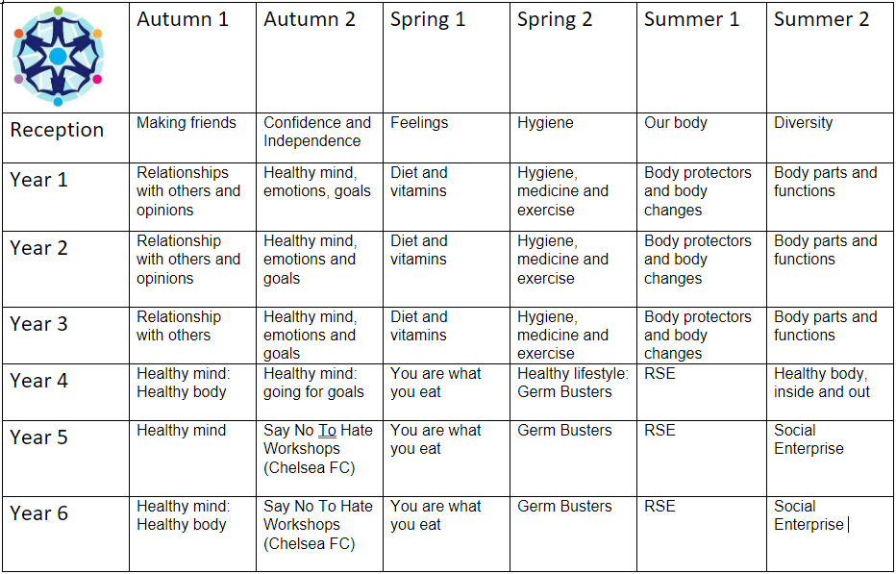

Medium term planning

EYFS – Year 6 use the Rising Stars Champion scheme for their medium-term planning documents for coverage and progression of skills. This scheme, along with guidance from supplementary resources, provide teachers with exemplification for PSHE objectives. This ensures teachers stay in the required key stage and support the idea of depth before breadth.

All classes have a weekly circle time session (30 minutes). Teachers of the EYFS ensure the children learn through a mixture of adult led activities and child-initiated activities both inside and outside of the classroom. Additionally, PSHE is taught through an integrated approach and ad hoc lessons are taught throughout the year.

Lessons

In all lessons, learning objectives are clearly displayed and discussed.
The emphasis in lessons is to make teaching interactive and lively, to engage all children encouraging them to talk about science. Lessons involve various elements.

- Instruction – giving information and structuring it well.
- Demonstrating – showing, describing and modelling scientific concepts using appropriate resources and visual displays.
- Explaining and illustrating – giving accurate and well-paced explanations.
- Questioning and discussing.
- Consolidating.
- Reflecting and evaluating responses – identifying mistakes and using them as positive teaching points.

Pupils’ Records of work

Children are taught a variety of methods for recording their work and are encouraged and helped to use the most appropriate and convenient. Within PSHE, lots of mind maps and brainstorming work is completed, either as a whole class or individually.
Children’s own jottings to support their work is encouraged throughout all year groups.

Marking

Work is marked against success criteria (I cans), in line with the school marking policy, and includes next steps where appropriate. Children are encouraged to self-assess their work and given time to read teachers’ comments and make corrections or improvements. Responses to marking are made as close to the work as possible, ideally at the start of the next lesson.
Due to the nature of most PSHE lessons being more conversational, often next steps are given verbally through use of questioning.

Assessment

Teachers assess the children’s work in PSHE by making informal judgements as they observe them during lessons. We have clear expectations of what the pupils will know and understand at the end of each year and key stage. Assessment should offer the children the opportunity to reflect on their own progress. Within the Foundation Stage, PSHE objectives are documented within ‘big books’ which include specific focused PSHE objectives and circle time activities. Similar to this, Key Stage One and Two also have a class scrapbook where circle time discussions are recorded, pictures of activities that are completed during PSHE lessons and any comments made by children that are relevant to the topic are included. The PSHE subject leader is responsible for monitoring the standards of children’s work and the quality of teaching. The subject leader will monitor plans, teaching and learning in order to evaluate strengths and weaknesses in the school and indicate areas for improvement. The subject leader will regularly evaluate the scheme of work to ensure that the needs of the pupils are being met and that there is progression and continuity of learning through the school.
Pupil Progress meetings are timetabled each term for all classes. Progress of pupils is discussed, and appropriate intervention considered and put in place where appropriate.

Special educational needs & disabilities (SEND)

Weekly PSHE lessons are inclusive to pupils with special educational needs and disabilities. Where
appropriate, children’s IEP’s incorporate suitable objectives from the National Curriculum for PSHE or development Matters and teachers keep these in mind when planning work. These targets may be worked upon within the lesson as well as on a 1:1 basis outside the lesson. Within the weekly PSHE lesson, teachers have a responsibility to not only provide additional scaffolding or activities to support children with SEND but also activities that provide sufficient challenge for children who are high achievers. It is the teachers’ responsibility to ensure that all children are challenged at a level appropriate to their ability.

Equal Opportunities

Positive attitudes towards PSHE are encouraged, so that all children, regardless of race, gender, ability, or special needs, including those for whom English is a second language, develop an enjoyment and
confidence with PSHE. This policy is in line with the school’s ‘Racial Equality’ policy.

The aim is to ensure that everyone makes progress and gains positively from lessons and to plan inclusive lessons. Lessons involving lots of visual, aural and kinaesthetic elements will benefit all children including those for whom English is an additional language

Links to other relevant policies
- Behaviour
- RSE policy
- Anti-bullying
- Child Protection and Safeguarding
- Online safety
- SEND inclusion

